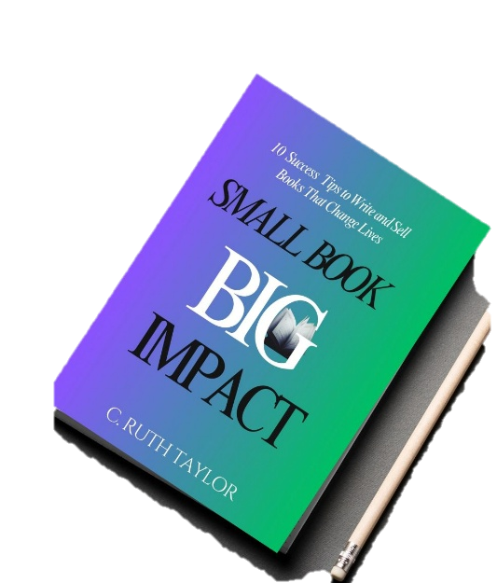

Small Book … Big Impact Challenge
Preparation Worksheet

This worksheet is based on the questions asked at the end of some of the chapters in “Small Book… Big Impact”.
Answer as many questions as you like as you prepare for the “Small Book… Big Impact 30-Day Writing Challenge.” All are not compulsory

Affirmation
I can and I will write a small book with a big impact.

Section 1: Generating Book Ideas
- What type of book do you want to write? Is it fiction, non-fiction, devotional, educational, memoir, children’s, poetry, inspirational, journal, workbook, etc

- How many words are you aiming for?

- Is this a solo book or part of an anthology?

- Can you identify 1-3 small books that could serve as models or writing guides for your book? List them here.

- Why do you want to write this book, no matter what. List 1-3 reasons

Section II: Your Story/Memoir Book Ideas
- What 3-10 experiences from your life stand out as impactful and could serve as the heart of your story?

- What challenges have you faced that could form the foundation of your memoir?

- What messages do you want your readers to take away from your story?

- Does your story have a message of hope, transformation, or redemption? How does it inspire others?

- Is there one defining season or event in your life that could be captured in a short memoir?

Section III: Central Ideas or Core Message (s) of the Book
- What themes in your life or experiences resonate with people universally (e.g., love, loss, resilience)?

- What timeless lessons or truths do you want your readers to take away from your book?

- Think about a book that has inspired you across different seasons of your life. What made it timeless, and how can you replicate that in your writing?

- If someone read your book 50 years from now, what impact would you want it to have on them?

- What life lessons have you learned that could inspire others? How can you weave these lessons into your writing?

- Think of a moment when you displayed resilience or courage. How can that experience shape your book’s message?

- How can your book encourage readers to persevere through their own hardships?

- If your book could teach one life-changing lesson to your readers, what would it be?

Section IV: Engaging and Valuable Content

- How can you make your book concise while still delivering value?
- What strategies can you use to grab and maintain your readers' attention?
- Reflect on books you've finished quickly—what made them engaging?
- How can your book cater to modern readers' busy lives?
- What techniques can you use to leave a lasting impression in fewer pages?

Section V: Purpose and Use of Book + Marketing & Promotion Ideas

- What opportunities might a book create for you in terms of recognition, influence, or financial success?

- Think of a famous person whose book helped elevate their status. What can you learn from their journey?

- If your book could make one significant contribution to the world, what would it be?

- What events or traditions in your community, culture, or faith could tie into your book's theme?

- How could you create an annual event or celebration around your book?
- What long-term strategies can you implement to keep your book relevant beyond the launch?

- How can you leverage current events or societal movements to sustain your book’s influence over time?

- Reflect on a book that has been celebrated annually—what impact did this event have on its legacy?

